SINDH MADRESSATUL ISLAM UNIVERSITY

SOFTWARE PROJECT MANAGEMENT

SUBMITTED TO MR. HASAN ZAIDI

**GROUP MEMBERS:**

**AYMAN FATIMA (CSC-17S-027)  
FASIHA RIAZ (CSC-17S-105)**

**SEMESTER: 6-C**

**DRAW A COMPARISION IN BETWEEN THREE MODELS WITH THE ASPECTS OF ITS APPLICATIONS. MENTION VALUABLE ASPECTS OF MODEL.**

Ayman Fatima, Fasiha Riaz

Department of Computer Science

SINDH MADRESSATUL ISLAM UNIVERSITY, KARACHI, PAKISTAN

***ABSTRACT - To have a conceptual study in between the SDLC models to have awareness of it, with the maximum aspects of it. This paper enhances the importance of reliability and high-quality system for the development of the software. This paper is consisted of the thought of the people related choosing the model for the better development of the software. This paper is consisted of Agile mode, incremental model and iterative model with the real time examples of it for the better comparison of the model with the real life. The real-life example of the model also increases the knowledge.***

***Keywords: SDLC, real life example, incremental model, iterative model, agile model.***

**INTRODUCTION:**

SDLC is a mechanism to plan, design and develop the software with the well-defined steps. It is the broad terminology that is now consisted of the various model, but it’s depended on us to choose the model according the requirement. It is the step by step processing of the construction of the model to get the product/software on time with fully functionalized characteristics.

SDLC stands for Software development Life Cycle. It is the mechanism that bounds the models in it for building the software. If it has not existed up till yet, then it is hard today to maintain the software. Now, the software is fully furnished with the user requirements and got ended on the given time. All functionalities are also set with in that specific phase of the cycle.

On the very first, the user requirements have also gathered for the processing of the software then the brainstorming happens. After it, the planning is happened as per brainstorming and then the software is constructed as per the requirements of the Customer. At the end, the software is delivered to the customers as per requirements.

There are various SDLC models involved in the software Construction. Models include:

* Waterfall Model.
* Incremental.
* Iterative.
* Big Bang Model.
* Spiral.
* V- model.
* Evolutionary development model.
* Agile.

SDLC contains the proper processing for the software development in a meaningful way. The mentioned are the planning phases of the SDLC model that is required for the proper analyzing, planning and constructing the software.

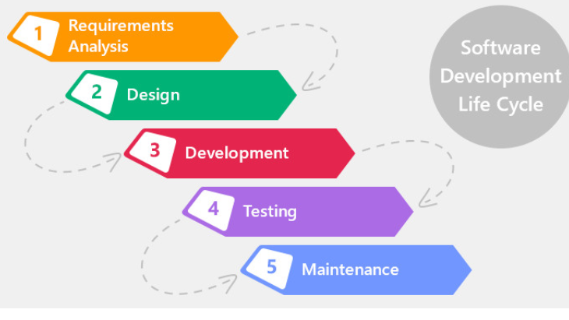

1. **AGILE MODEL:**

The agile model shows the iteration process. The parts of the agile model break down into smaller pieces for the better development of the product, the parts do not undergo for the long-term processing. The divided parts are known as frame in agile model. The project is divided to minimize the risk from the project. The requirement was defined at the starting of the project, but it may be enhanced time to time by the clearance of the project so in this methodology, agile is used to welcome the new requirements and then implement it.

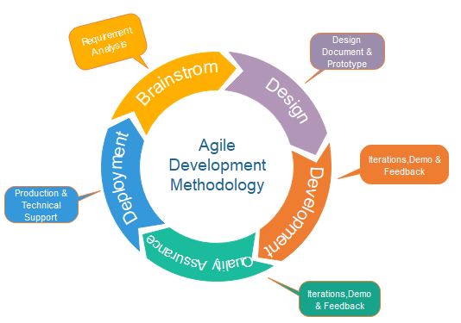

* 1. **PHASES OF AGILE MODEL:**

Phases of agile model includes:

1. Requirement gathering.
2. Design.
3. Construction.
4. Testing.
5. Deployment.
6. Feedback.

**REQUIREMENT GATHERING:**

this is the phase in which the user describes the requirements, that needed to build the actual product as user want. It is in the form of information for the structure of the project due to which the economic and technical feasibility is defined.

**DESIGN:**

Now the time arrives to select the stakeholder for the project. In this phase the UML diagram is designed to check the feasibility of the project and if it is designed right then the construction will be happened according to the processing steps of the diagram.

**CONSTRUCTION:**

Now all the team is united, and working has been started in this phase. This is the key phase because the frontend and backend are designed by the developers for the deploying purpose.

**TESTING:**

In this phase the Quality assurance teamwork for the removing of bug from the program, if exists.

**DEPLOYMENT:**

The product is about to deploy in this phase to the right customer because the product now has been designed and tested (free from all bugs) so it is the right time to deploy it.

**FEEDBACK:**

After deployment, it’s time to get feedback from the customer related product. It has importance because the faults are easily identified so it should be removed.

* 1. **METHODS OF AGILE TESTING:**

There are few agile testing methods, which are named as:

1. Scrum
2. Crystal.
3. DSDM.
4. FDD
5. Extreme programming.

**SCRUM:**

It is the methodology in which the work is done through team management. The three roles are: scrum master, product owner and scrum team. The scrum master sets the whole system and manages the team. The product owner manages the information regarding product and create a log. The scrum team manages the work to complete the cycle.

**CRYSTAL:** It is also dividing into three categories: chartering, cyclic delivery and wrap up. Chartering phase includes so many activities such as develop a team, work for the feasibility of the product, analysis of product and developing plan. Cyclic delivery includes the two phases like in one, the team make sure the update of the release plan and in second one to deploy the integrated parts to the customers.

**XP:**

The extreme programming methodology applies where the requirements get change continuously by the customer.

**DSDM:** It is also the agile methodology for the product development. It also termed as rapid development. In this method, the team directly connects with the users for getting decisions from the users.

**FDD:**

It is based on “to design and then to build”. It is the small steps processing for describing into single functionality.

* 1. **REAL-TIME APPLICATIONS:**

the real time applications of agile model are:

* + 1. RESTAURANT MANAGEMENT:

Sprint planning: when the food has already been cooked by the cook before opening the restaurant.

Adhoc stories: when the continuous orders are delivered to the customers.

Velocity: it is termed under the situation in which the successful orders are calculated.

* + 1. CRICKET TEAM MANAGEMENT:

Scrum master: the captain or the coach of the team come under scrum master methodology.

Scrum team: the team, that plays cricket and manage the team.

Velocity: it is the targeted term used for the run rate.

1. **INCREMENTAL MODEL:** It is the model, in which the requirements are divided into further sub-requirements for the processing of it, then every requirement ends with the proper construction and testing of the divided module.

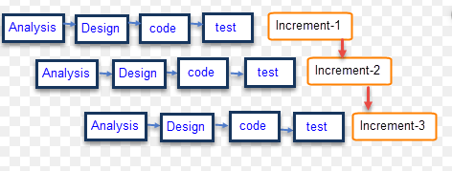

* 1. **PHASES:**

1. Requirement analysis.
2. Design and development.
3. Testing.
4. Implementation.

**REQUIREMENT ANALYSIS:**

It is the main part of the incremental model because in this phase the requirements are gathered by the user and are being analyzed by the analysis team for further processing. In this phase, both functional and non-functional requirement is gathered for the development of product.

**DESIGN AND DEVELOPMENT:**

In this phase, both designing, and development is combined. The design is happened first for better construction of functionality-based product.

**TESTING:**

It is the phase in which the whole product is tested by the QA team and they remove all the possible upcoming bugs from the product.

**IMPLEMENTATION:**

In this phase, the coding is added for the enhancement of product.

* 1. **WHY INCREMENTAL MODEL:**
* The priorities requirements can be constructed first due to this methodology.
* When the customer wants some piece of product urgently.
* Quick working model.
* All the requirements working simultaneously so the product will also be delivered on time.
  1. **ADVANTAGES:**
* Easy to work.
* Easy to identify errors.
* Easy to test.
  1. **DISADVANTAGES:**
* Cost would be high.
* Planning should be good.
* working team should be trained one.
* Integration of the part.
  1. **REAL-TIME APPLICATION:**
     1. **IN LOADING PICTURE:**

The photograph generating technique is also based on incremental model because when the picture is loaded, it is incremented step by step. Process does wait for the first part to be completed for generating the second half part. So, in the step 01, half of the picture is loaded. In step 02, the second part will be loaded after the complete generation of step 01 and the step 03 works same as previous steps.

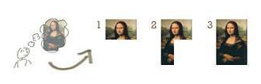

* + 1. **DESIGNING PICTURE:**

The picture designing methodology is also depended on incremental model. In this technique, firstly the part is drawn, after completing it the picture maker wants to add one more part for fully designed picture. In this way the performance is going on with respect to last step.

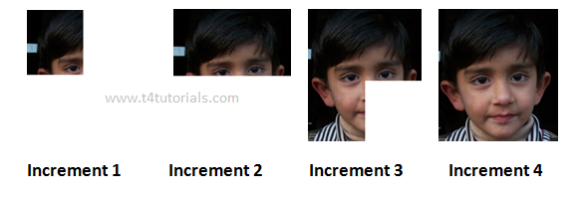

* + 1. **WANT TO HAVE SOCIALIZING:**

If a person wants to have a socializing and want to send friend request through any social app, then he/she will surely go to have account on that app, they do sign up first then they do log in into that application and then they find the friend and send friend request to that particular friend. In this way, the incremental model is used for the processing of the step to get the required result.

1. **ITERATIVE MODEL:**

in this model, the project development begins from the specification and end up making a product, if that product is the first version and any problem would occur then the second release will also occur with that same iteration. All the iteration is consisted of all the phases for proper development and testing.

* 1. **PHASES:**
* Requirement gathering.
* Design.
* Implementation.
* Testing.
* Deployment.
* Review.
* Maintenance.

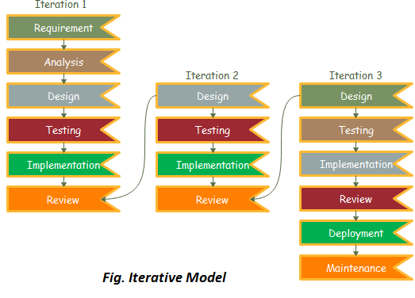

**REQUIREMENT GATHERING:**

It is the first stage of the iterative model in which the functional and non-functional requiremensts are taken from the customer. Analyst from the team, checks the customer’s requirement whether it comes under successful critera or not.

**DESIGN:**

It is the phase in which the diagram are designed for the construction of the project. It is the prototyping phase of the sdlc.

**IMPLEMENTATION:**

In this phase, all the requirements are being written in the form of programming language.

**TESTING:**

It is the phase the product is tested by the team.

**DEPLOYMENT:**

It is the phase in which the product is deployed to the customer.

**REVIEW:**

In this phase, reviews are taken from the customers. If it is got fail, then again the phases gets start from the first phase for the construction of the product.

**MAINTENANCE:**

If the error has been arrived then it’s time to safe the product from the error and do maintain it.

* 1. **WHY ITERATIVE MODEL:**
* When requirements have been defined clearly.
* When the project is large.
  1. **REAL-TIME APPLICATION:**

it is applicable in the smartphones versions as well, because the intermediaries take reviews from the customers related smartphone and if something went wrong or want to have a update then the update version is released that occupies al the features, which were not present in the last model.

**CONCLUSION:**

All the SDLC models are important according to the requirements. If the customer’s

requirement may change in any phase of the development or he/she wants to have some specific functionalities then the agile methodology applies to restart the product development from the first phase. It can easily moves back, get requirement and applies it into the product. If the product development occurs in the form of modules, or the requirements are broken down into part for efficient development then the incremental development applies. It is the easiest way to complete requirements, because all the requirements are constructed individually and can be deployed as well. Iterative model achieves when there is a need to update the product then the iteration occurs and new product will be developed in it.

REFERENCES:

<https://www.researchgate.net/publication/258959806_A_Comparison_Between_Five_Models_Of_Software_Engineering>

<http://ijrti.org/papers/IJRTI1802003.pdf>

[https://sci-hub.tw/https://www.sciencedirect.com/science/article/abs/pii/S0305054816302076](https://sci-hub.tw/https:/www.sciencedirect.com/science/article/abs/pii/S0305054816302076)